52nd KVS REGIONAL SPORTS MEET 2023
U-19 BOYS ATHLETICS
S. No. | No. of Participant | Name of Position Holder | Events | Achievement | Remarks
1 | 4 | Monu Kumar , XIIB | 1. Long jump  2. High jump  3. Triple jump  4. 4*100m Relay  5. 4*400m Relay | Gold  Gold  Gold  Silver  Silver | Selected for National for the events( Long Jump & Triple Jump)
2 |  | Ashwin Manoj Mathew, XIA | 1. 4*100m Relay  2. 4*400m Relay | Silver  Silver
3 |  | Dilpreet Singh XIIB | 1. 4*100m Relay  2. 4*400m Relay | Silver  Silver
4 |  | Dipanshu , XIIA | 1. 4*100m Relay  2. 4*400m Relay | Silver  Silver
U-19 GIRLS ATHLETICS
1 | 4 | Anshu Sunariya , XIIB | 1. Long jump  2. 4*100m Relay | Bronze  Bronze
2 |  | Marya Kumari , XIIA | 1. 4*100m Relay | Bronze
3 |  | Monika, XIIA | 1. Shot-put  2. 4*100m Relay | Bronze  Bronze
 |  | Prakashni, XIIB | 1. 4*100m Relay | Bronze
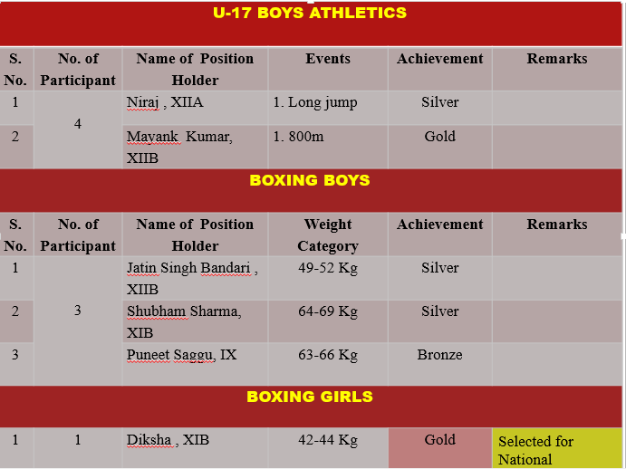
U-17 SKATING BOYS
S. No. | No. of Participant | Name of Position Holder | Events | Achievement | Remarks
1 | 1 | Sourav Kumar , IX | 1. 500m  2. 1000m | Bronze  Bronze
U-14 SKATING GIRLS
1 | 1 | Gurleen Kaur , VIB | 1. 500m | Bronze
U-17 SKATING GIRLS
3 | 1 | Navneet ,X | 1. 500m  2. 1000m | Bronze  Bronze
U-19 TEAKWONDO GIRLS

S. No. | No. of Participant | Name of Position Holder | Weight Category | Achievement | Remarks
1 | 1 | Jaswinder Kaur , XIIB | 55-59 Kg. | Gold | Selected for National
U-19 SKATING GIRLS
1 | 1 | Tejaswini ,XIIB | 1.500m(Quad.)  2. 1000m(Quad.) | Gold
